**2022799605**

Credit Card Bill Total – Showing £436.02

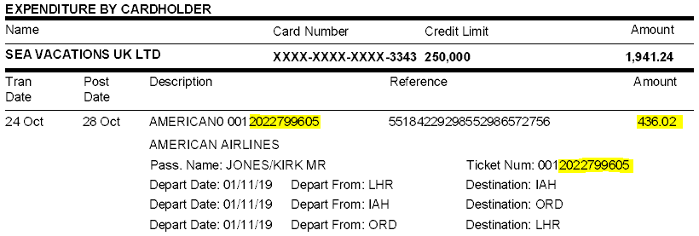

Central Command Totals

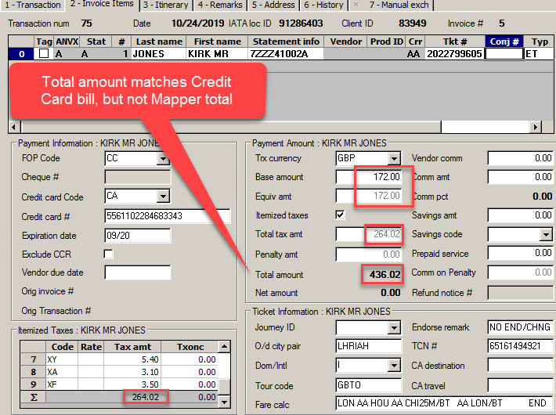

Mapper Ticket Totals

**The fare appears to be correct in GBP for this particular ticket but the tax amount is not matching. As a result, the sum of the ticket total is not matching between the Credit Card bill/Central Command, and Mapper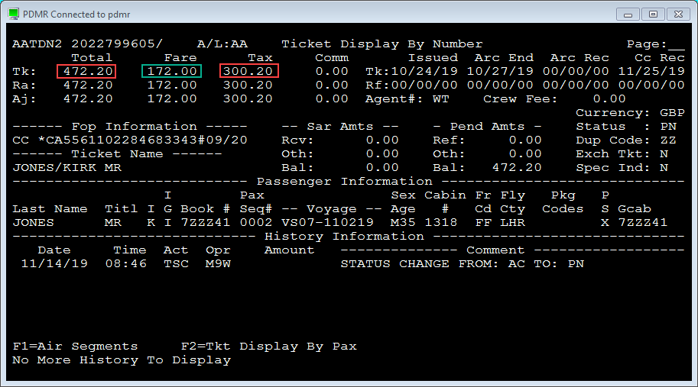

Mapper Journal Entry Totals

**Journal entry is picking up GBP as the entry currency Mapper Ticket Total in GBP, and giving a USD equivolent amount based on the incorrect GBP amount.

